2022 MG National Meeting
“MGs by the Lake”
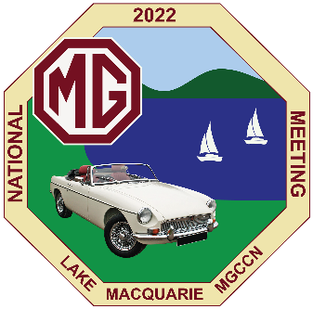
Bulletin 4 - January 2022
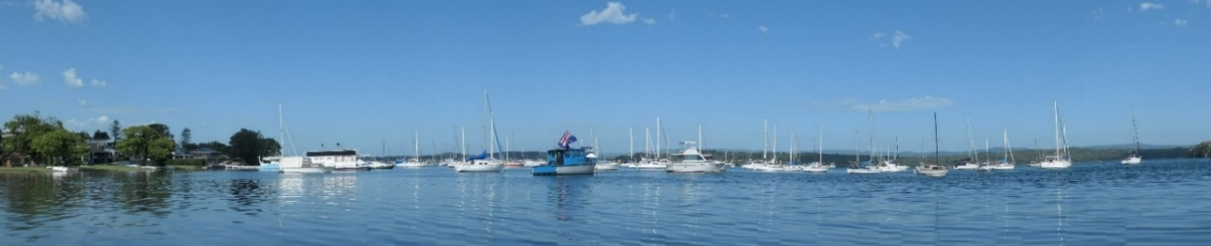

Well, the Omicron strain has caused much concern since Bulletin 3 in November. However, be assured that Nat Meet 2022 will be proceeding, with registrations opening next week. The only thing that would stop the event now is a major tightening of Government regulations.
Registrations open Monday 24th January
Registrations will open on Monday 24th January and close on Wednesday 16th March.
Discounted “Early Bird” rates are available up until Wednesday 23rd February, with savings of $50 per head for adults.
Careful planning has kept the registration fees low, making this the most affordable National Meeting in recent years.
Entry forms will be available on the Nat Meet website from 24th January and will be sent directly to Club Secretaries and those who have completed an EOI.
Maximum Numbers of Registered Entrants
As mentioned in Bulletin 3, our social venues will enable us to cater for around 350 entrants, although that would reduce to around 300 if current covid restrictions continue. The motorkhana and hillclimb venues can accommodate around 100 competitors each.
Expressions of interest have been received from more than 360 people who say they are likely to attend, so it is possible that numbers may have to be capped. If so, entries will be accepted on a strictly “first come, first served” basis.
Some Reminders and Event Updates
Photographic Competition:
Remember to bring along your best photos featuring an MG theme or car/s to enter in the photo competition. Entries are to be submitted at Registration and must not have not been entered at a previous National Meeting. Full details are in the Supp Regs. Please remember that the size of photographs is restricted to a maximum 250mm x 200 mm (10 inch x 8 inch). Categories are:
- Best Action photograph
- Best Still photograph
- Best Novelty photograph
- Best Digitally manipulated photograph

Scenic Tour Options on Lake Macquarie:
For anyone looking for something else to do on the day of the Concours, other than inspecting all the beautiful MGs, a ferry service has recently commenced around the northern half of Lake Macquarie. Lake Mac Ferry departs from the Speers Point jetty (right at the Concours venue) and cruises to 5 different stops. There are multiple departures throughout the day, and routes and travel times vary between 1½ and 2 hours. See Lake Mac Ferry for more details.
For those with deeper pockets and a higher thrill tolerance, JoyAir operates scenic joy flights in a floatplane over the lake and the adjacent coastline. Pickup can be booked to collect from Speers Point Park. See JoyAir for more details.
Theme Night:
Our Theme Night on Saturday evening will celebrate the 60th anniversary of the launch of the MGB, so we will be going “Back to the Sixties”. We look forward to seeing plenty of mini-skirts, knee-high boots, flared trousers and paisley shirts as we have a fun time celebrating the “good old days”.
Covid-19 Uncertainty
We are proceeding on the basis that Nat Meet will go ahead, but we are aware that many of you will be feeling uncertain about committing in the current environment. With that in mind, the committee has undertaken to refund all registration fees in full if the event has to be cancelled due to a major tightening of Government restrictions concerning Covid-19 management for events.
Note that entries may be withdrawn for other reasons up to 16th March with a full refund. After 16th March a cancellation fee of $50 will apply and after 1st^{h} April no refund will be granted unless Nat Meet is cancelled.
In the meantime, please “roll up your sleeves” for your covid booster vaccination at the earliest possible opportunity, and we look forward to seeing you all at Nat Meet 2022.

Contacts for more Information:
Website - natmeet2022.mgcarclub.com.au
Registration enquiries – Raechel Fraser (0401 624 819) – registrar.mgnatmeet2022@gmail.com
Chair - Bruce Fraser (0417 481 480) – chair.mgnatmeet2022@gmail.com
Secretary - Fran Hodgson (0414 449 252) – mgnatmeet2022@gmail.com

